**Problem 1:** Inheritance in Java.

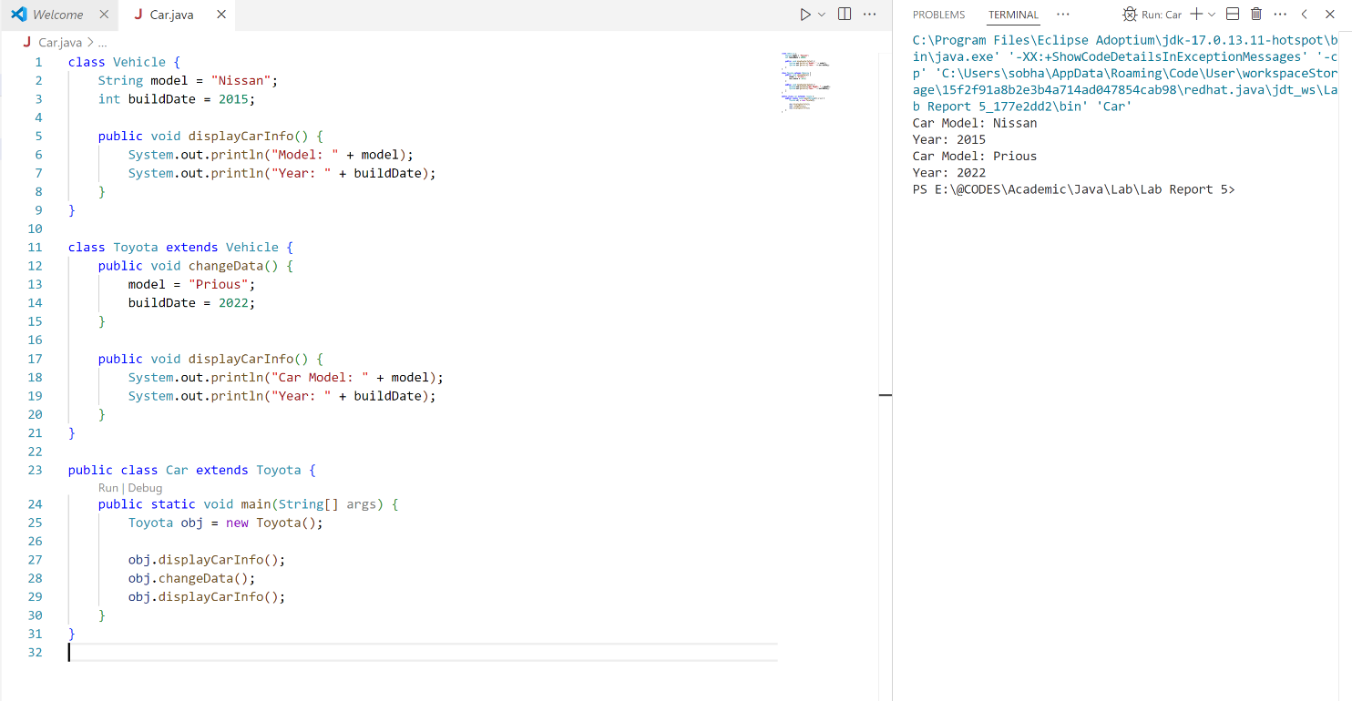

**Problem 2:** Java Inner Classes

